Reading Wise 1 AK
Unit 1 – The Rat and the Cat
Pre-Reading
Answers will vary.

Vocabulary Preview
1. c 2. e 3. a 4. d 5. b

Understanding the Key Ideas
1. d 2. b

Reading Comprehension
1. F 2. T 3. c 4. a 5. b 6. b

Language Focus
1. c 2. e 3. b 4. a 5. d

Picture Story
A. a. 3 b. 1
c. 2 d. 4
B. (Answers may vary.)
1. The king hated rats because they were dirty.
2. He ordered his servants to find a good cat.
3. The rat followed the cat, and it got very tired.
4. The king said he was wrong. The cat was brave and clever.

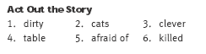
Summary
1. servants 2. dirty 3. palace 4. jumped
5. turned 6. killed 7. waited 8. capture

Expansion Questions
Answers will vary.

Unit 2 – The Fox and the Crow
Pre-Reading
Answers will vary.

Vocabulary Preview
1. c 2. a 3. e 4. b 5. d

Understanding the Key Ideas
1. a 2. c

Reading Comprehension
1. T 2. F 3. c 4. b 5. d 6. a

Language Focus
1. e 2. a 3. c 4. b 5. d

Picture Story
A. a. 2 b. 4
c. 3 d. 1
B. (Answers may vary.)
1. A crow sat in a tree with a piece of bread in her beak.
2. The fox said she was a wonderful bird with beautiful feathers and a beautiful voice.
3. The crow opened her beak. When she screamed “caw!” the bread fell.
4. The fox said she has a loud voice but not a clever brain.

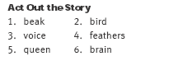

Summary
3, 7, 1, 8, 4, 5, 2, 6

Expansion Questions
1.
Fur | dog, fox, wolf
Feathers | chicken, crow, duck, goose, peacock, sparrow
Hair | donkey, elephant, horse

2. Answers will vary.

Unit 3 – The Fire Dogs
Pre-Reading
Answers will vary.

Vocabulary Preview
1. c 2. a 3. e 4. d 5. b

Understanding the Key Ideas
1. c 2. d

Reading Comprehension
1. F 2. T 3. c 4. d 5. a 6. b

Language Focus
1. c 2. a 3. c

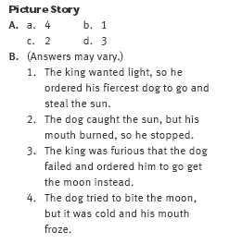
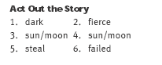
Summary
1. fiercest 2. bring it 3. raced toward 4. its heat
5. exhausted 6. froze 7. also failed 8. an eclipse of

Expansion Questions
Answers will vary.

Unit 4 – Barking Like a Dog
Pre-Reading
Answers will vary.

Vocabulary Preview
1. c 2. a 3. d 4. e 5. b

Understanding the Key Ideas
1. b 2. c

Reading Comprehension
1. T 2. T 3. b 4. a 5. d 6. b

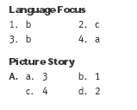
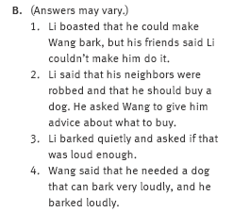
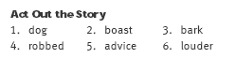

Summary
8, 2, 5, 4, 7, 1, 3, 6

Expansion Questions
Answers will vary.

Unit 5 – A Dog and His Reflection
Pre-Reading
Answers will vary.

Vocabulary Preview
1. d 2. c 3. a 4. e 5. b

Understanding the Key Ideas
1. d 2. c

Reading Comprehension
1. F 2. F 3. c 4. a 5. b 6. a

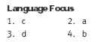

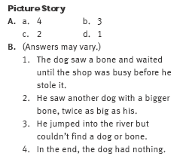
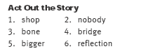

Summary
1. butcher’s 2. bridge 3. twice 4. opened
5. river 6. another 7. reflection 8. nothing

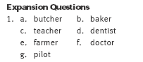
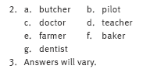

Unit 6 – The New Bed
Pre-Reading
Answers will vary.

Vocabulary Preview
1. d 2. e 3. b 4. c 5. a

Understanding the Key Ideas
1. c 2. d

Reading Comprehension
1. F 2. F 3. a 4. d 5. b 6. b

Language Focus
1. a 2. c 3. b

Picture Story
A. a. 2 b. 3
c. 4 d. 1
B. (Answers may vary.)
1. Zhang bought a new bed that cost a lot of money
2. He told his friends that she was ill and must stay in bed.
3. Wu wanted his friends to see his new shoes.
4. Zhang told Wu he thought they both had the same illness.

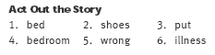
Summary
3, 5, 4, 8, 6, 2, 1, 7
Expansion Questions
1. a. f b. g
c. e d. h
2. Answers will vary.

Unit 7 – The Hen and the Rooster
Pre-Reading
Answers will vary.

Vocabulary Preview
1. e 2. d 3. a 4. b 5. c

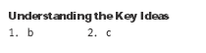

Reading Comprehension
1. T 2. F 3. b 4. d 5. c 6. a

Language Focus
1. kind 2. happily 3. sadly 4. kindly 5. happy

Picture Story
A. a. 2 b. 3
c. 1 d. 4
B. 1. A man bought a big, fat hen and took it home.
2. A rooster flew around his head.
3. The rooster dropped a piece of gold in front of the man.
4. The man realized the rooster and the hen wanted to be together.

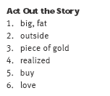

Summary
1. bought 2. flapped around 3. understand 4. outside
5. standing close 6. gold coin 7. buy the hen back 8. happily

Expansion Questions
1.
Male | Female
rooster | hen
bull | cow
lion | lioness
tiger | tigress
ram | ewe
2. Answers will vary.

Unit 8 – The North Wind and the Sun
Pre-Reading
Answers will vary.

Vocabulary Preview
1. c 2. e 3. a 4. b 5. d

Understanding the Key Ideas
1. d 2. c

Reading Comprehension
1. T 2. F 3. a 4. b 5. c 6. b

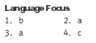

Picture Story
A. a. 4 b. 2
c. 3 d. 1
B. 1. The north wind and the sun were arguing. Both said that they were stronger.
2. They saw a man on the road. Whoever could make the man take his coat off would be the winner.
3. The wind blew hard, but the man pulled his coat tighter around him.
4. The sun shone gently, and the man took off his coat and put it in his bag.

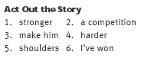

Summary
4, 5, 3, 8, 6, 7, 1, 2

Expansion Questions
Answers will vary.

Unit 9 – The Uncle and the Nephew
Pre-Reading
Answers will vary.

Vocabulary Preview
1. e 2. a 3. d 4. b 5. c

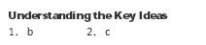

Reading Comprehension
1. F 2. T 3. b 4. c 5. a 6. a

Language Focus
1. happy 2. a lot 3. barely 4. grassland 5. go away from

Picture Story
A. a. 3 b. 2
c. 1 d. 4
B. 1. When his nephew came to visit, the uncle was pleased.
2. The nephew ate a lot of food.
3. The uncle had no food left because he had killed all the chickens.
4. The uncle told the nephew that he had been there for over a week, and it was time to go.

Act Out the Story
1. visit 2. food
3. chickens 4. leave
5. came 6. field
7. week 8. plenty

Summary
1. visit 2. inside 3. any food left 4. worry
5. arrived 6. grass 7. leave 8. plenty to eat

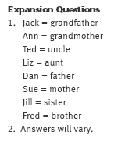

Unit 10 – No Food for Lunch
Pre-Reading
Answers will vary.

Vocabulary Preview
1. c 2. a 3. d 4. e 5. b

Understanding the Key Ideas
1. a 2. c

Reading Comprehension
1. T 2. F 3. b 4. c 5. d 6. a

Language Focus
1. a and c 2. b and d
3. b and c

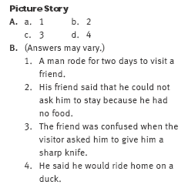
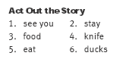

Summary
2, 3, 8, 1, 7, 5, 6, 4

Expansion Questions
Across Down
3. journey 1. together
7. surprised 2. meal
8. chicken 4. ducks
9. visitor 5. sharp knife
6. garden

Unit 11 – The Thief’s Coat
Pre-Reading
Answers will vary.

Vocabulary Preview
1. d 2. a 3. e 4. b 5. c

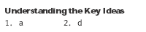

Reading Comprehension
1. F 2. T 3. c 4. b 5. d 6. a

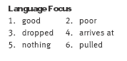
Picture Story
A. a. 4 b. 2
c. 1 d. 3
B. 1. The thief looked for something to steal while the poor husband and wife were asleep.
2. The thief took off his coat to pour rice in.
3. The husband pushed the thief’s coat under the bed.
4. The thief asked how there could be no thief when his coat had been stolen.

Act Out the Story
1. sleeping 2. good idea
3. in my coat 4. push
5. frightened 6. stolen
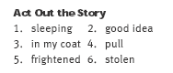

Summary
1. poor man 2. steal 3. on the floor 4. pour
5. under the bed 6. woke up 7. nothing to steal 8. had stolen

Expansion Questions
Answers will vary.

Unit 12 – The Flying Cow
Pre-Reading
Answers will vary.

Vocabulary Preview
1. d 2. c 3. e 4. b 5. a

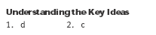

Reading Comprehension
1. T 2. F 3. c 4. d 5. c 6. b

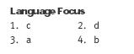
Picture Story
A. a. 3 b. 2
c. 4 d. 1
B. (Answers may vary.)
1. A farmer had a strange dream that his cow grew wings and flew away.
2. He believed his dream and sold his cow.
3. He bought a bird and tied the cloth bag with his money in it to its leg.
4. The bird flew away with the cloth bag and all his money.

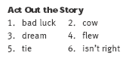

Summary
8, 3, 1, 5, 2, 6, 7, 4

Unit 13 – The Big Lie
Pre-Reading
Answers will vary.

Vocabulary Preview
1. d 2. c 3. e 4. b 5. a

Reading Comprehension
1. F 2. F 3. b 4. a 5. b 6. a

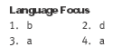

Picture Story
A. a. 3 b. 1
c. 4 d. 2
B. (Answers may vary.)
1. The man said he hear that Tan was good at lying and asked him to tell a big lie.
2. Tan said that he couldn’t tell a lie just then because the lake was empty and everyone was trying to catch the fish.
3. The old man ran as fast as he could to the lake.
4. The lake was not empty, but was just as full as ever.

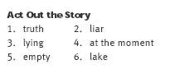

Summary
1. liar 2. believed 3. lie 4. wise
5. lost 6. promised 7. as fast as 8. as full as

Expansion Questions
Answers will vary.

Unit 14 – Freeing the Birds
Pre-Reading
Answers will vary.

Vocabulary Preview
1. d 2. a 3. b 4. e 5. c

Understanding the Key Ideas
1. a 2. c

Reading Comprehension
1. T 2. F 3. d 4. a 5. c 6. b

Language Focus
1. b 2. d 3. a

Picture Story
A. a. 3 b. 4
c. 1 d. 2
B. (Answers may vary.)
1. Li saw a man selling a bird. He bought it and took it home. Then he released it.
2. Li’s wife asked why he was buying so many birds.
3. He said he let the birds go free because it was lucky.
4. His wife was angry and said people should not be allowed to catch birds.

Act Out the Story
1. birds
2. go free
3. let a bird
4. catch
5. will die
6. wrong

Summary
3, 5, 7, 8, 2, 6, 1, 4

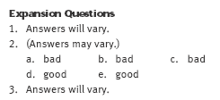

Unit 15 – The Eyes
Pre-Reading
Answers will vary.

Vocabulary Preview
1. c 2. e 3. a 4. b 5. d

Understanding the Key Ideas
1. c 2. d

Reading Comprehension
1. T 2. T 3. b 4. d 5. c 6. b

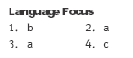
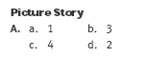
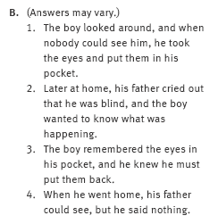
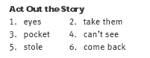

Summary
1. Outside 2. glass eyes 3. tickets 4. pocket
5. blind 6. terrified 7. back into 8. fine

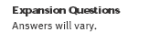

Unit 16 – The Leaning Tree
Pre-Reading
Answers will vary.

Vocabulary Preview
1. c 2. d 3. e 4. a 5. b

Reading Comprehension
1. F 2. T 3. b 4. a 5. d 6. a

Language Focus
1. c 2. d 3. a

Picture Story
A. a. 3 b. 1
c. 4 d. 2
B. (Answers may vary.)
1. The rich man thought he was cleverer than everyone.
2. The rich man laughed at the poor man. He said the man was too stupid to get a job he was much smarter.
3. The poor man ran away from the tree and didn’t come back.
4. The rich man realized that he was not as clever as the poor man.

Act Out the Story
1. too stupid
2. job
3. maybe
4. ten
5. want
6. fall

Summary
3, 4, 7, 2, 5, 1, 6, 8

Unit 17 – The Hat
Pre-Reading
Answers will vary.

Vocabulary Preview
1. c 2. e 3. a 4. b 5. d

Understanding the Key Ideas
1. c 2. b

Reading Comprehension
1. T 2. T 3. b 4. a 5. c 6. a

Language Focus
1. b 2. d 3. c

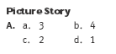
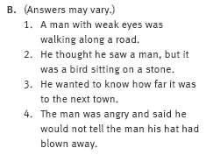
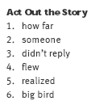

Summary
1. very well 2. traveling along 3. stone 4. far away
5. spoke louder 6. flew away 7. blown away 8. continued

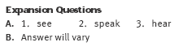

Unit 18 – The Thief and the Policeman
Pre-Reading
Answers will vary.

Vocabulary Preview
1. c 2. e 3. b 4. a 5. d

Understanding the Key Ideas
1. b 2. d

Reading Comprehension
1. F 2. T 3. b 4. c 5. a 6. b

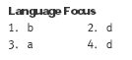
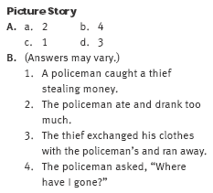
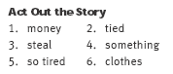

Summary
1, 4, 5, 7, 3, 2, 8, 6

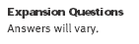

Unit 19 – The Birthday Present
Pre-Reading
Answers will vary.

Vocabulary Preview
1. d 2. a 3. e 4. c 5. b

Understanding the Key Ideas
1. c 2. b

Reading Comprehension
1. F 2. T 3. d 4. a 5. a 6. a

Language Focus
1. b 2. a 3. b

Picture Story
A. a 2 b. 3
c. 4 d. 1
B. (Answers may vary.)
1. The people in the office asked, “What shall we buy him? A watch or a tie?”
2. The boss was pleased with his present and said, “Thank you.”
3. The workers wanted to get a similar gift for their boss’s wife.
4. The boss told them she was born in the Year of the Ox.

Act Out the Story
1. were born 2. present
3. Thank you 4. very much
5. similar 6. the Ox

Summary
1. present 2. watch or a tie 3. Year of the Rat 4. gold
5. same size 6. love it 7. similar 8. Year of the Ox

Unit 20 – Mr. Wang’s Animals
Pre-Reading
Answers will vary.

Vocabulary Preview
1. d 2. a 3. c 4. b 5. e

Understanding the Key Ideas
1. c 2. b

Reading Comprehension
1. T 2. F 3. b 4. d 5. c 6. a

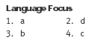
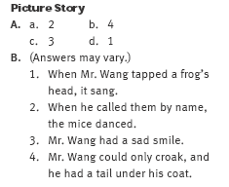
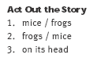
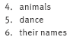

Summary
3, 8, 6, 7, 4, 2, 5, 1

